QUOTATION
Dated:
TO WHOMSOEVER IT MAY CONCERN
Particluars | Professional Fees | Govt Fee
1. Filing of Form 26 to take authorization to represent at the Patent Office. | 0 | 320
2. Filing Fresh Form 1 and Form 5, if needed with petition | 0 | 1600 (u/r 137) or 10,000 per month (u/r 138)
3. Filing Form 6 and doing Assignment deed | 5000 | 800
4. Filing an affidavit and Form 13 to add an inventor | 2000 | 800
5. To file Form 18 to file Request For Examination | 2000 | 4000
6. To Analyze requirement of any data about Technical Significance/ Synergistic Effect and ensure compliance of the same with discussion with inventors | 8000
7. Furnishing the Information to the Patent Office in an affidavit regarding Technical Significance/ Synergistic Effect | 8000
8. Filing Form 8 to include inventor names on the certificate | 2000
9. Address the Objections of FER | 15000
10. Filing Form 30 to notify the controller regarding attending the hearing | 3000 | 1500
11. Attend the hearing and provide written submission till grant | 20000
TOTAL | 65000 | 19020


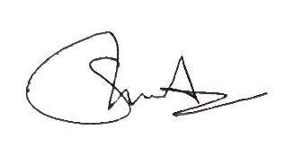
Note: Stamp duty charges are applicable of Rs. 3000 along with 18% GST on Professional Fees.
Best Regards,

Adv. Amin Sharan Kumar
CEO, Athena Legal

